Lab - PowerShell Core 7 using VS Code

This lab is to learn and get some hands-on experience of using VS Code for PowerShell Core 7.

**Perform the lab and do full desktop screen write ups.**

**Indicate time taken, issues and if any, how you fixed them**

**Step 1:** Open VS code and create a new file there, write command Write-Host “Hello World!” and save it with “.ps1” extension. Run the file it will launch the terminal inside the VS Code. Make sure that we are running PowerShell Core 7 and the extension for PowerShell on VS Code is already installed.

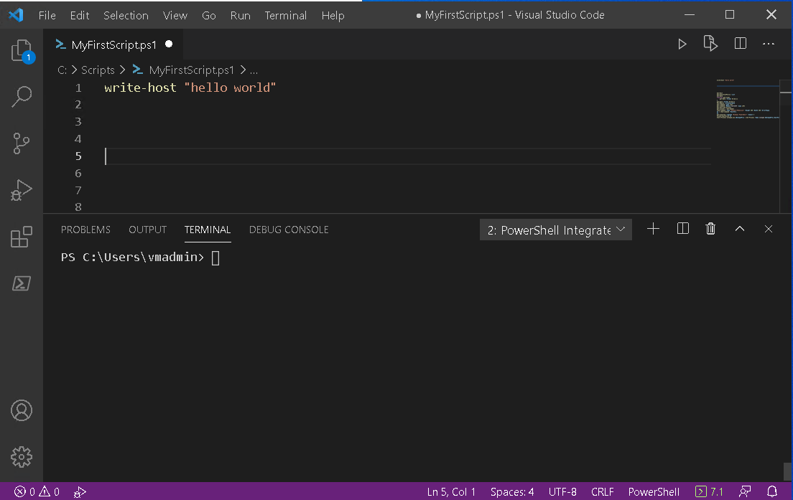

Note: Always select and hit F8 key to run each command separately

**Step 2:** Once the whole setup is done, run the file and observe the changes made inside the terminal. Try using the path of your Script C:\Scripts\MyFirstScript.ps1 inside the terminal to call the script and check what happens.

**Step 3:** Type in Get-ExecutionPolicy -List and check what it shows. Paste the snippet and explain.

**Step 4:** To check the date and time execute the following commands

Get-Date  
Get-Date -format hh:mm:ss

After performing both commands check and write the difference between both. Paste Snippets

**Step 5:** Try  
 Function get-time  
 {   
 get-date -format hh:mm  
 }   
 get-time  
select and run the command using F8 key. Describe and paste snippets

**Step 6:** Type in command Get-Module -ListAvailable and observe the running terminal to check the packages of functions you have paste snippets.

**Step 7:** Try Get-Command after running the command run Get-Command -Name *IP* and Get-Command -Module NetTCPIP -Name *IP*. Examine the difference between both the commands describe and paste snippets

**Step 8:** Enter the command below inside your script and run it check what happens and paste snippets and write.

Start-Process notepad.exe  
$NotepadProc = Get-Process -Name notepad   
$NotepadProc.WaitForExit()  
StartProcess calc.ex

**Step 9:** Pipe commands run Get-Process | Get-Member inside your script and verify the results. PowerShell is case sensitive language. Explain and paste snippets.